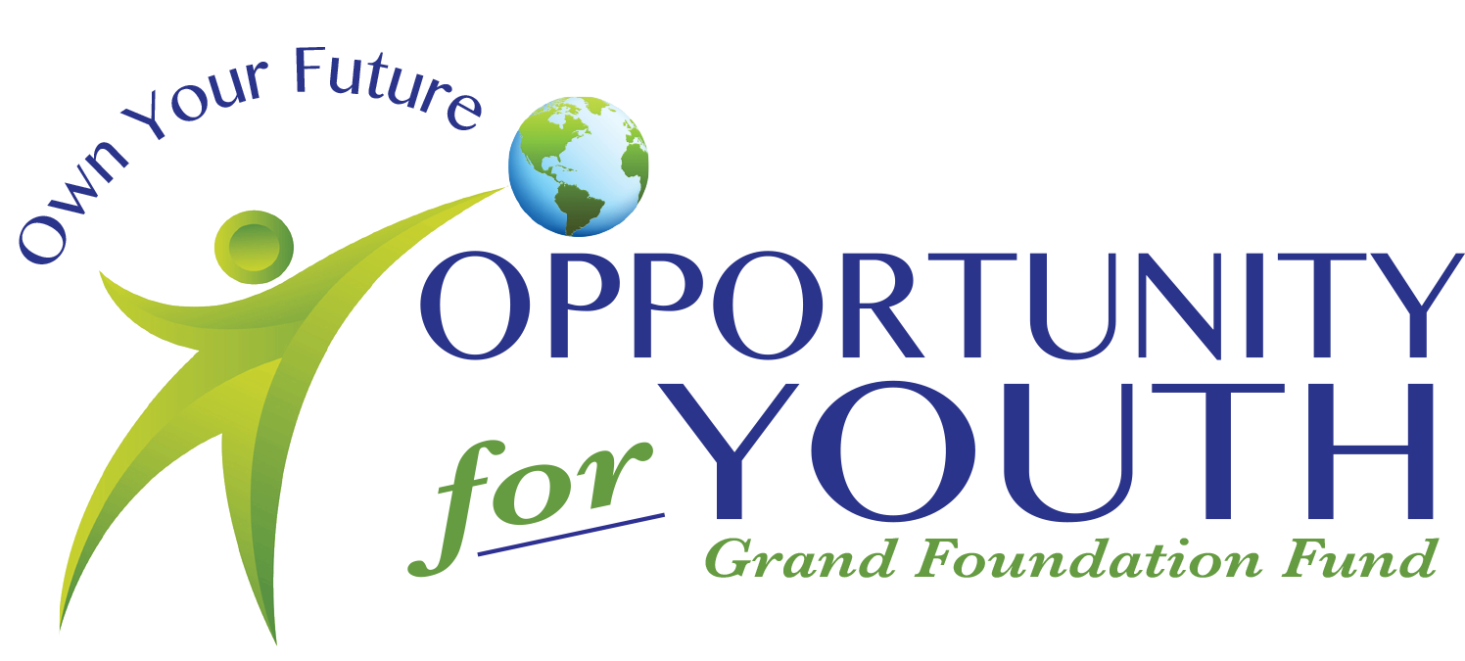
August 5, 2026
The Opportunity for Youth Fund of the Grand Foundation invites you to sponsor the 6th Annual Grand County Casino Royale, being held Friday, September 18th at the Headwaters Event Center in Winter Park. This event will feature fun and games including Blackjack, Texas Hold ‘Em, Roulette, Craps, food, drinks, music, and more!

The Grand County Casino Royale sponsorships generate funds which help support the Opportunity for Youth Fund of the Grand Foundation (OYF). The mission of OYF is to transform the lives of youth, build self-esteem, and empower them to strive to be their best. The fund aims to support Grand County youth to participate in activities they may not be able to financially afford otherwise. Sponsoring Grand County Casino Royale is an opportunity for you to give back to the youth in our community while enjoying an evening surrounded by games, food, drinks, and fun!

With your sponsorship, you will receive recognition at the event, as well as on social media and marketing materials leading up to and following the event. The Grand County Casino Royale provides a unique opportunity to promote your brand to a broad spectrum of businesses and individuals who represent the local community, the front-range, the State of Colorado, and visitors from across the country. Your participation will help ensure that this event is a celebrated success.

If you have any questions regarding the Grand County Casino Royale, please feel free to contact the Grand Foundation at 970-887-3111 or by email at info@grandfoundation.com.

Please secure your 2026 Grand County Casino Royale sponsorship by August 20, 2026.

Thank you,
Megan A. Ledin

Megan Ledin
Executive Director

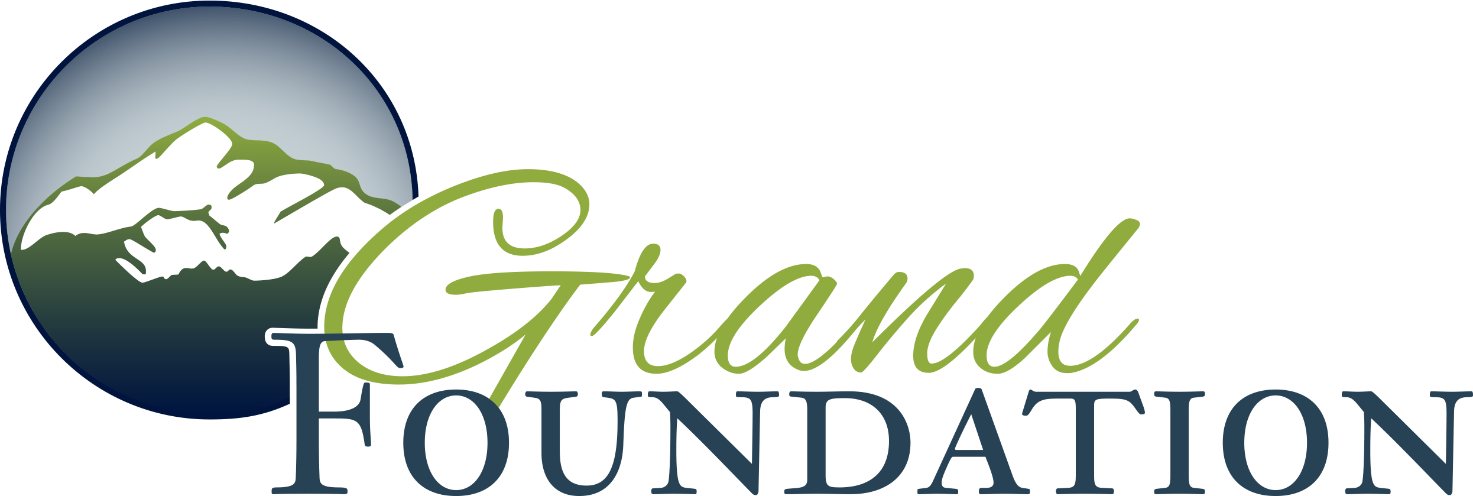

Grand Foundation ~ P.O. Box 1342 ~ Winter Park, CO 80482 ~ 970.887.3111

